**ACTIVITY 10(Lab-05)**

Name:- Abhishek Srivastava

Registration Number:- 19BCE10071

Course:- NAS2001- Advanced Data Analytics

Slot:- B21+B22+B23

Faculty:- Dr. Nilamadhab Mishra

Q. Investigate any classification problem for a dataset and try to implement those three algorithms i.e. Decision Tree, Naïve Bayes, K-Nearest Neighbours, and analyse the classification accuracy and other performance factors of each type of algorithm.

1. Decision Tree

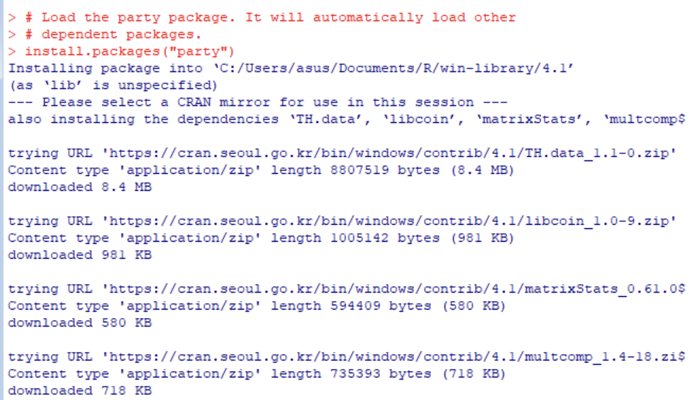



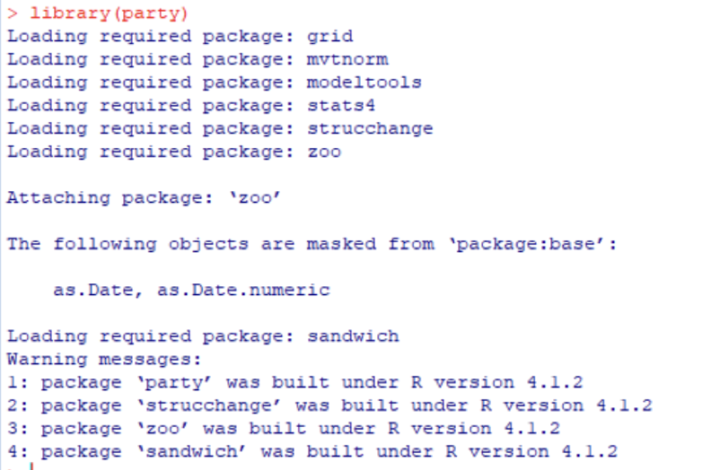



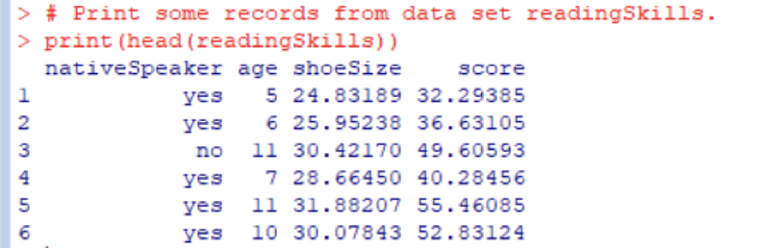



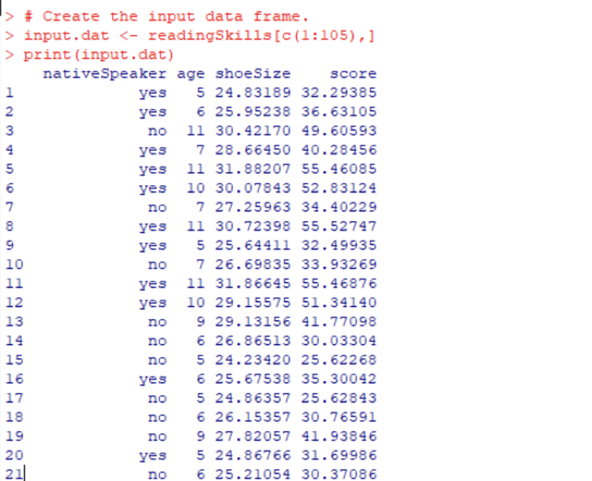



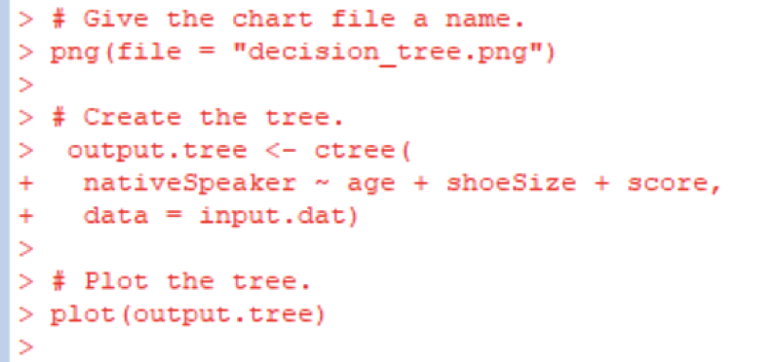



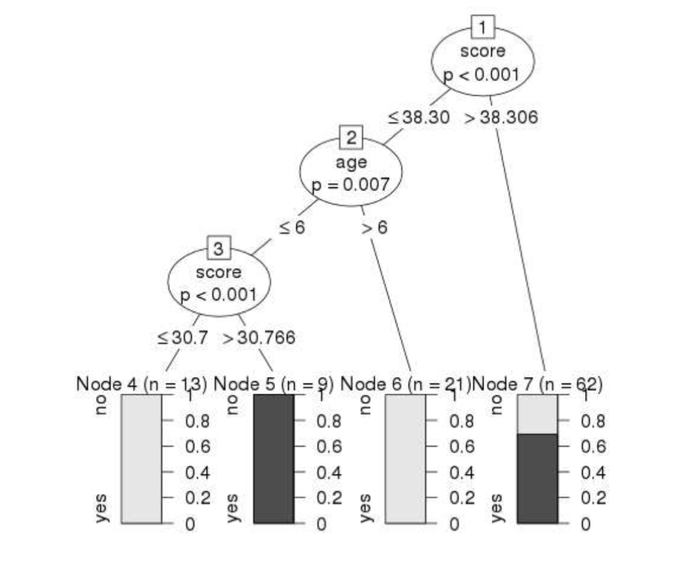

1. Naïve Bayes

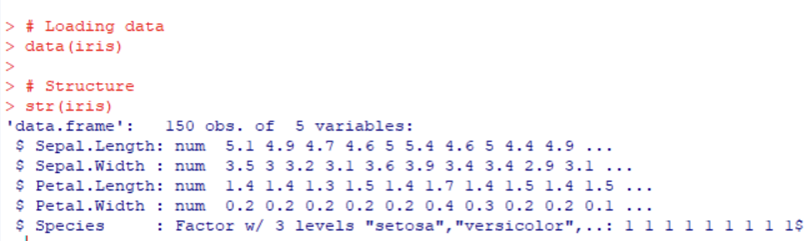



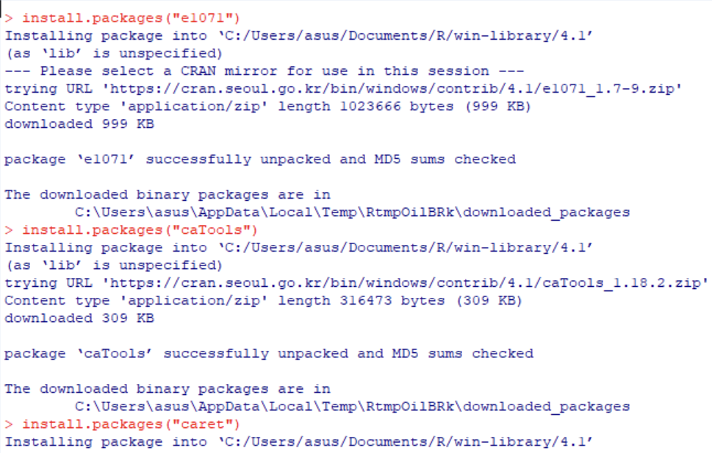



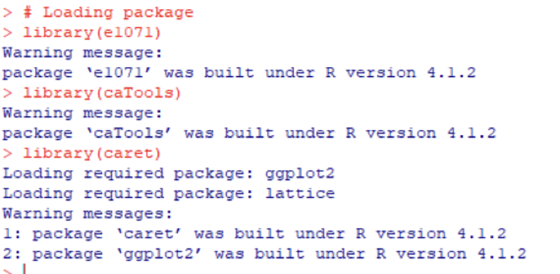



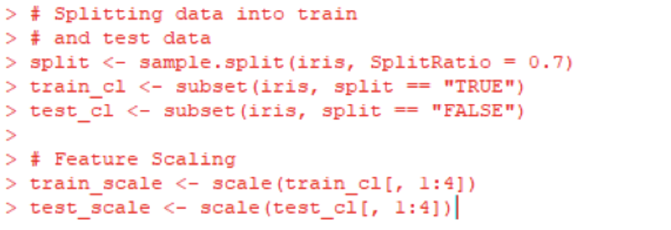



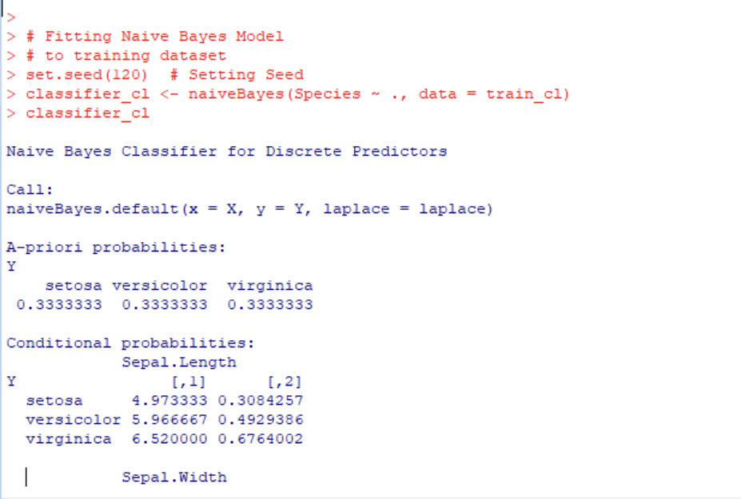



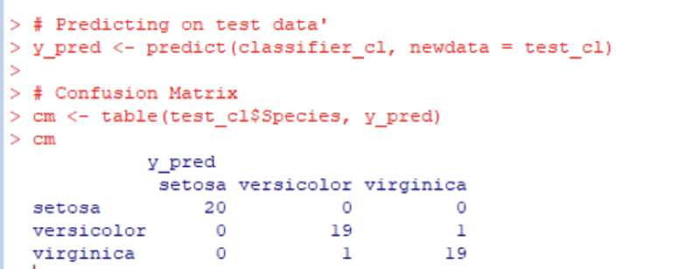



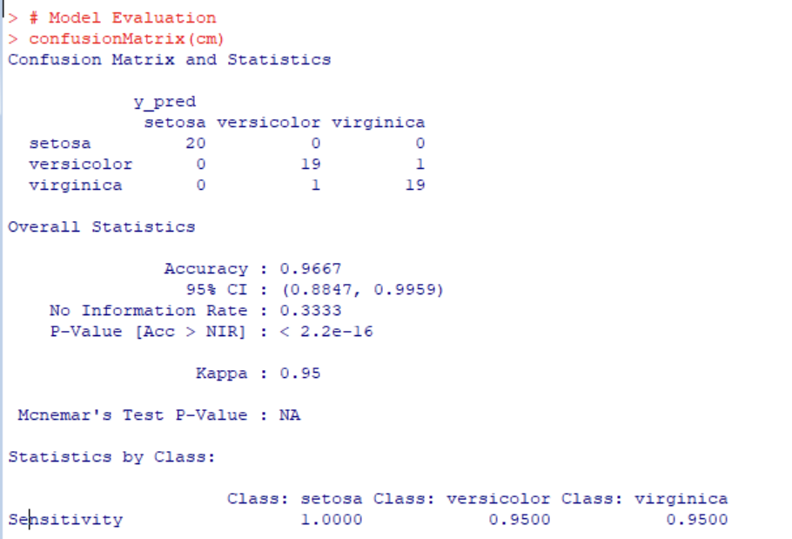

1. K-Nearest Neighbours

